Title: | Window lifter  SW Component

History
Issue status  (Index) | Maturity/Date  (draft/invalid/valid)  (dd-mmm-yyyy) | Author  Department | Check/Release  Department | Description
1.0 | Draft  26-06-15 | Edgar Mosqueda | Edgar Mosqueda | Creation of the document

Table of Contents
1 Purpose 3
2 Definitions and abbreviations 3
3 Realization constraints and targets 3
4 SW Conceptual design 3
5 SW Component internal breakdown 4
5.1 Functional Decomposition 4
5.2 Function <Type> <function name> (type par 1, .., type par n) 5
5.3 Function <Type> <function name> (type par 1, .., type par n) 5

Purpose
Window lifter is the module responsible to control the window movement. Window lifter is controlled by two switches that indicate the direction of the window movement.

Definitions and abbreviations
Definitions
Anti pinch  Manual mode  Auto up  Invalid condition | Definer esto

Abbreviations
Only SW Component specific abbreviations.
References
N° | Document name | Reference
1 | SW Architecture description

Realization constraints and targets
For this purpose the window has to be emulated using a 10 led bar. The movement of the window has to be simulated turning on/off the LEDS creating the animation of the window movement. The time between each transition shall be 400 msec. There are two possible window movements, up and down. Each window movement has to be indicated trough a led color. Depending on movement each led has to be turn on, UP BLUE and DOWN GREEN. In order to consider a validate button press; the button has to be pressed at least 10 msec. The module has to be able to detect fail button press. In that case the button press or button combination has to be considered as invalid.
Anti pinch is a feature than prevents accidents between window and some human body parts like arms, hands, head. In this case the signal than indicates to the module the detection of a pinch will be a push button. This signal just can be considered as valid when the movement is UP. If this signal is valid then the module has to stop the UP Movement and then DOWN the window until the window get totally OPEN. After window is totally OPEN the module has to ignore during 5 seconds all button press. After window is totally OPEN the module has to ignore during 5 seconds all button press. After this time the module has to recognize every button press.

SW Conceptual design

For this software we need to create specifics functions, it will view in the next list:
- A function responsible to configure at time of execution.
- A function monitoring at 10ms for to validate the press buttons
- A function for manual mode.
- A function anti pinch.
- A function for automatic up mode, but this function will view steadly if anti pinch is validate for the interruption its execution.
- The function automatic down mode will recycle of anti pinch, because thous do the same, but it can run in all moment.

SW Component internal breakdown

Functional Decomposition
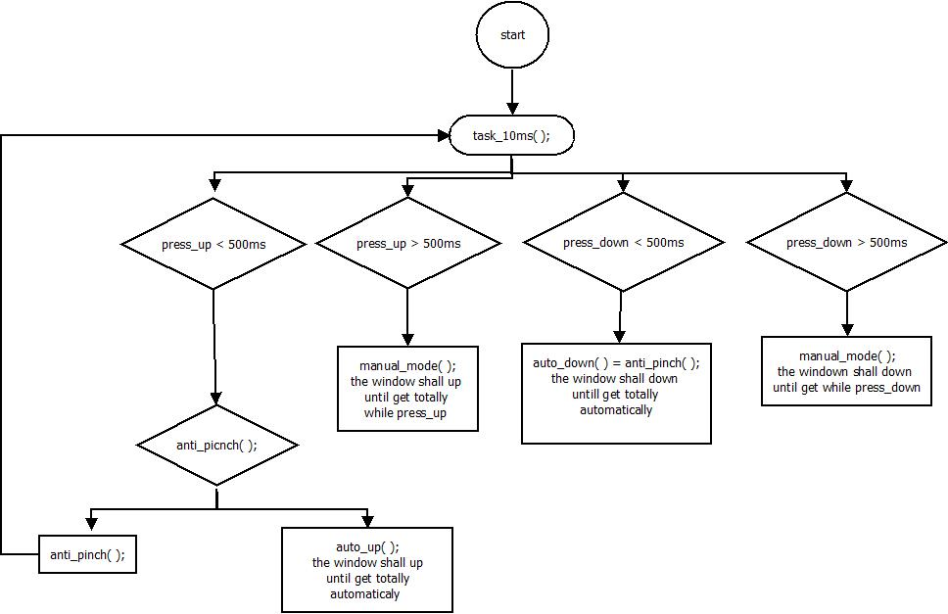
Function Description and Dynamic Behavior

Function void delay (void)

Description | Create a dealy between transition
Parameter | void
Precondition | This function is called for to do transition of 400ms
Error Conditions

Function void manual_mode (void)
Description | This function there is a counter for up and down
Parameter | void
Precondition | this function is called for changes manuals
Error Conditions

Function void dummy_500us (void)
Description | This function is responsible for the configure the base time
Parameter | Void
Precondition | this function is called with the interruption of MC
Error Conditions

Function void dummy_endless_loop (void);
Description | This function is responsible of enable a pointer to structure into dummy_500us( )
Parameter | Void
Precondition | this function is an infinite loop
Error Conditions

Function void Task_10ms (void);
Description | This function is responsible of validate press_up, press_ down and anti_picnch
Parameter | Void
Precondition | this function is called each 10ms
Error Conditions

Function void anti_pinch (void);
Description | This function is responsible for prevents accidents between window and some human body parts like arms
Parameter | Void
Precondition | This function is called when detect obstruction.
Error Conditions

Function void delay_pinch (void);
Description | This function is a special delay
Parameter | Void
Precondition | This function is called into anti_pinch( ) for to do waiting 5 seconds than restarts the system.
Error Conditions

